How to read data from database table?
To read data from database table, python program send “SELECT” statement.
SELECT command read data from database table and store inside cursor object.

How to read data from cursor object?
In order to read data from cursor object, cursor object provides the following methods.
- fetchone()
- fetchmany()
- fetchall()

fetchone(): This method read single row from cursor. This method returns each row as tuple. If there are no rows inside cursor object it returns None.

Example:
import mysql.connector as mysql
cn=mysql.connect(database="database7pm",
user="root",
password="root",
host="localhost",
port="3306")
c=cn.cursor()
c.execute("select * from student")
r1=c.fetchone()
print(r1)
r2=c.fetchone()
print(r2)
r3=c.fetchone()
print(r3)
r4=c.fetchone()
print(r4)
cn.close()

Output
(1, 'naresh', 'python')
(2, 'suresh', 'java')
(3, 'kishore', 'c++')
None

fetchmany(n)
This method fetch/read “n” row from cursor object.
This method returns list contains each row as tuple
If there are no row to fetch it returns empty list.

Example:
import mysql.connector as mysql
cn=mysql.connect(database="database7pm",
user="root",
password="root",
host="localhost",
port="3306")
c=cn.cursor()
c.execute("select * from student")
rows=c.fetchmany(2)
print(rows)
rows=c.fetchmany(2)
print(rows)
rows=c.fetchmany(2)
print(rows)
cn.close()

Output
[(1, 'naresh', 'python'), (2, 'suresh', 'java')]
[(3, 'kishore', 'c++')]
[]

fetchall()
This method read all the rows from cursor object.
This method returns list contains each row as one tuple.
If no rows to fetch, it returns empty list

Example:
import mysql.connector as mysql
cn=mysql.connect(database="database7pm",
user="root",
password="root",
host="localhost",
port="3306")
c=cn.cursor()
c.execute("select * from student")
rows=c.fetchall()
print(rows)
rows=c.fetchall()
print(rows)
cn.close()

Output
[(1, 'naresh', 'python'), (2, 'suresh', 'java'), (3, 'kishore', 'c++')]
[]

Example:
# Write a program to read the details of given empno

import mysql.connector as mysql

cn=mysql.connect(database="database7pm",
user="root",
password="root",
host="localhost",
port="3306")
c=cn.cursor()
empno=int(input("EmployeeNo:"))
SQL="select * from employee where empno=%s"
c.execute(SQL,params=(empno,))
emp=c.fetchone()
if emp==None:
print("Invalid EmployeeNo")
else:
print(emp)

cn.close()

Output
EmployeeNo:1
(1, 'naresh', 'manager', 51000.0)

EmployeeNo:3
(3, 'kishore', 'hr', 36000.0)

EmployeeNo:4
Invalid EmployeeNo

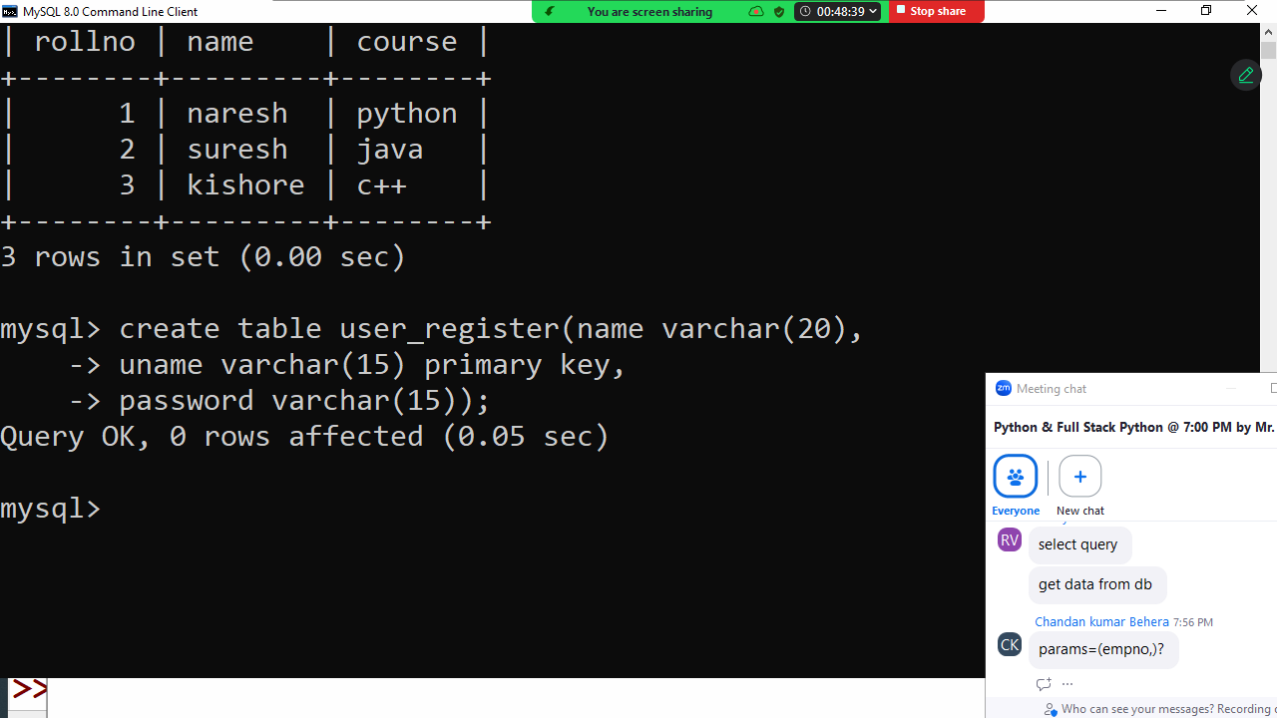

Example:
# Write a program to register user
import mysql.connector as mysql
cn=mysql.connect(database="database7pm",
user="root",
password="root",
host="localhost",
port="3306")
c=cn.cursor()
name=input("Name :")
uname=input("UserName :")
pwd=input("Password :")
SQL="insert into user_register values(%s,%s,%s)"
try:
c.execute(SQL,params=(name,uname,pwd))
print("User Registered")
cn.commit()
except:
print("Error in Registering User")
finally:
cn.close()

Output
Name :naresh
UserName :nit
Password :nit123
User Registered

Name :ramesh
UserName :nit
Password :xyz123
Error in Registering User

Example:
# Login program
import mysql.connector as mysql
cn=mysql.connect(database="database7pm",
user="root",
password="root",
host="localhost",
port="3306")
c=cn.cursor()
SQL="select * from user_register where uname=%s and password=%s"
for i in range(3):
uname=input("UserName :") # nit
pwd=input("Password :") # nit123
c.execute(SQL,params=(uname,pwd))
row=c.fetchone()
if row!=None:
print(f'{uname},welcome')
break
print("Invalid username or password")

if i==2:
print("Maximum attempts are completed")
print("Your account is blocked")

Output
UserName :nit
Password :nit123
nit,welcome

Example:
# Write a program to change password of user
import mysql.connector as mysql
cn=mysql.connect(database="database7pm",
user="root",
password="root",
host="localhost",
port="3306")
c=cn.cursor()
uname=input("UserName :")
opwd=input("Old Password:")
npwd=input("New Password:")
SQL="update user_register set password=%s where uname=%s and password=%s"
c.execute(SQL,params=(npwd,uname,opwd))
a=c.rowcount
if a>0:
print("password is updated")
else:
print("Invalid username or password")
cn.commit()
cn.close()

Output
UserName :nit
Old Password:nit123
New Password:nit321
password is updated

UserName :nit
Old Password:nit123
New Password:nit321
Invalid username or password

Example:
# write a program to delete an employee
import mysql.connector as mysql
cn=mysql.connect(database="database7pm",
user="root",
password="root",
host="localhost",
port="3306")
c=cn.cursor()
empno=int(input("Employeeno delete :"))
SQL="delete from employee where empno=%s"
c.execute(SQL,params=(empno,))
k=c.rowcount
if k>0:
print("Employee Deleted")
cn.commit()
else:
print("Invalid EmployeeNo")
cn.close()

Output
Employeeno delete :3
Invalid EmployeeNo

Employeeno delete :1
Employee Deleted

Python and Oracle database communication
In order to communicate with oracle database, python program required libraries.
- cx_Oracle
- oracledb

These libraries are provided Oracle Corporation.

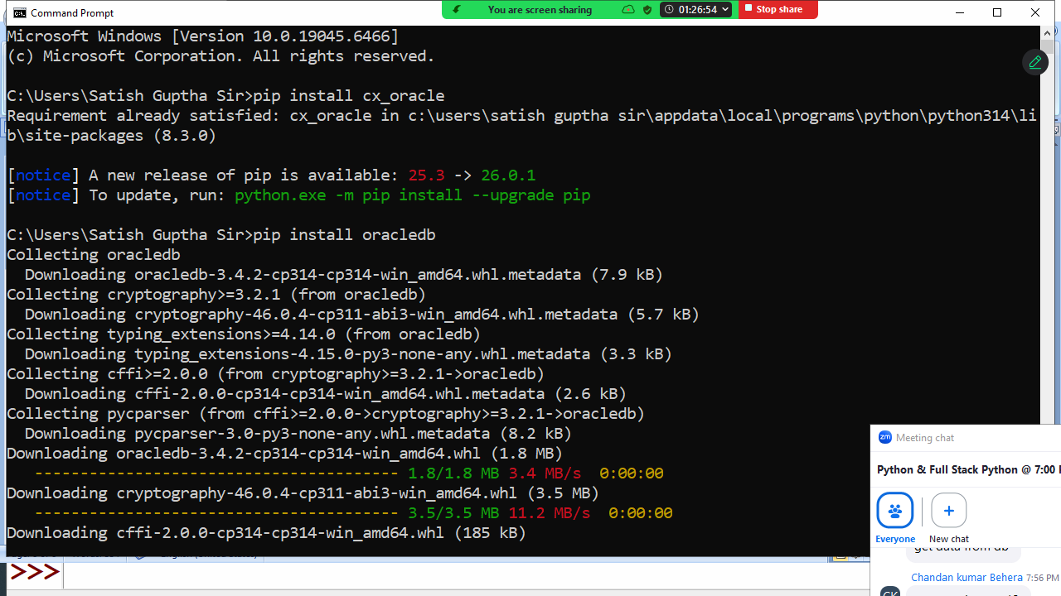

Before installing oracle libraries first install oracle database software.

